Remarkable Triangles

Problem 883
In this problem we consider triangles drawn on a hexagonal lattice, where each lattice point in the plane has six neighbouring points equally spaced around it, all distance 1 away.
We call a triangle remarkable if
- All three vertices and its incentre lie on lattice points
- At least one of its angles is 60°.
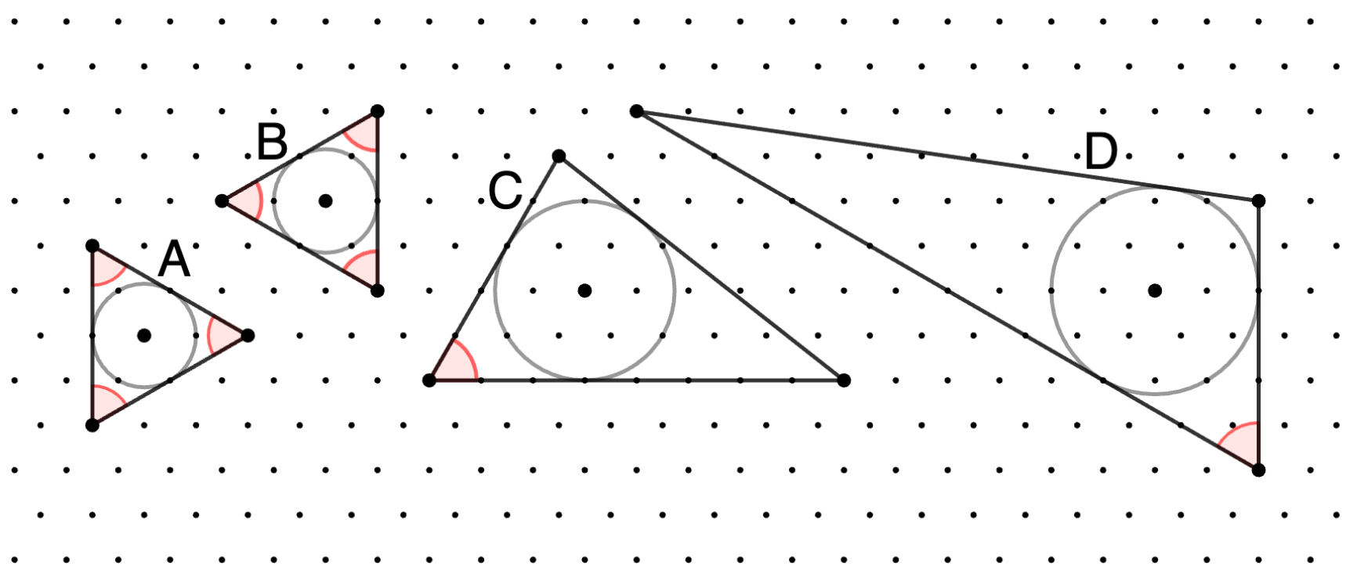
Above are four examples of remarkable triangles, with 60° angles illustrated in red. Triangles A and B have inradius 1; C has inradius ; D has inradius 2.
Define T(r) to be the number of remarkable triangles with inradius ≤r. Rotations and reflections, such as triangles A and B above, are counted separately; however direct translations are not. That is, the same triangle drawn in different positions of the lattice is only counted once.
You are given T(0.5) = 2, T(2) = 44, and T(10) = 1302.
Find T(10⁶).

The Lattice
The lattice points come in 2 flavors, based on their y-coordinate. Call the lower left corner of the diagram the origin.
Then the first row of points have coordinates (i, 0) where i is an integer. The third row have coordinates (i, ), the fifth (i, 2), … So the points in odd numbered rows have coordinates (i, j) for integers i, j.
The second row points have coordinates (i+½, /2). The fourth row points have coordinates (i+½, 3/2), the sixth (i+½, 5/2), … So the points in even numbered rows have coordinates (i+½, (j+½)) for integers i, j.

Example Triangles on the Lattice
Therefore the triangles in the diagram have these coordinates (CW starting at vert w/ 60° angle):
- A – (3/2, 3/2), (3/2, 7/2), (9/2, 5/2) → incentre @ (5/2, 5/2)
edge lengths = 2, 2, 2 inradius = 1
- B – (4, 4), (7, 5/2), (7, 3/2) → incentre @ (6, 4)
edge lengths = 2, 2, 2 inradius = 1
- C – (8, 2), (21/2, 9/2), (16, 2) → incentre @ (11, 3)
edge lengths = 5, 7, 8 inradius =
- D – (24, ), (12, 5), (24, 4) → incentre @ (22, 3)
edge lengths = 8, 7, 3 inradius = 2

Let’s translate the 60° vertex to the origin and see the other coordinates:
- A – (0, 0), (0, 2), (3, ) → incentre @ (1, )
- B – (0, 0), (3, ), (3, -) → incentre @ (2, 0)
- C – (0, 0), (5/2, 5/2), (8, 0) → incentre @ (3, )
- D – (0, 0), (-12, 4), (0, 3) → incentre @ (-2, 2)

A New Coordinate System
Define a pair of non-orthogonal unit vectors as a new basis:

Without loss of generality, we can require the triangle to have the 60° angle at the origin, one vertex

